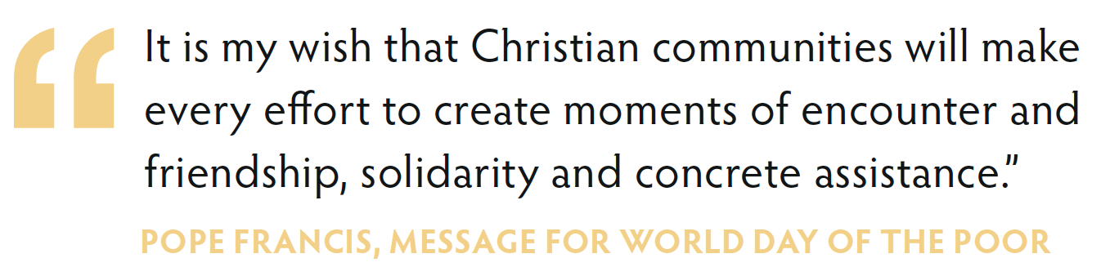
Ideas for
Action

During the celebration of the World Day of the Poor in your parish, you may have used, or been given, the ‘Moments of Encounter’ postcard during or after your Sunday Liturgy. The card encourages parishioners to consider how they might choose to encounter and walk with those experiencing poverty.

For Parish Teams
If you have distributed the postcard during your Masses, and received replies, please consider how to respond to the parishioners. This sheet is provided to offer some ideas for action under the six headings used on the postcard. You can use the sheet in various ways:
In Groups:
- Invite all who responded to come together. Use the sheet to discuss together (or split into groups based on interest), how you could respond to the needs of those living in poverty.
- Check within your deanery or neighbouring parishes. Can you do something together and link your local projects?
- Can you invite your diocesan Caritas office (or other local Caritas Agency) to help your parish discern?: http://www.csan.org.uk/member
- Use this conversation to lead into the ‘Love in Action’ parish programme, developed by Caritas Westminster and Caritas Social Action Network, to support parishes. See www.stepforwardinlove.org
Individually
- If you can’t offer people the opportunity to meet in a parish group, or through the deanery, contact each individual with a list of suggestions based on their reply on the postcard.
- If your parish resources don’t allow you to do this, then pass on this sheet to everyone who responded.

For Groups and Individuals
This sheet provides some ideas for actions, organisations and projects to support the choices that parishioners make. The sheet can be used individually, by a group, or by the Parish team to reply to parishioners and make suggestions about what they may wish to get involved in.

Those living in poverty in our local area
Responding to people living in poverty in your local area will, most likely involve some research. Who do you know who you can contact or talk to? Here are some ideas:
- Contact your local Caritas Agency, most of whom support people experiencing poverty. See a full list here - is one of them local to your parish: http://www.csan.org.uk/member
- Does your parish have an SVP group? Talk to them for ideas of how people can help.
- You can contact the SVP for support in setting up a group:

The SVP: is an international Christian voluntary organisation dedicated to tackling poverty and disadvantage by providing direct practical assistance to anyone in need. In England and Wales there are over 10,000 voluntary members who visit the lonely, the sick, the marginalised and the imprisoned. There are also ‘Special Works’ including holiday schemes, debt counselling, and support centres. http://svp.org.uk/

- Research other local organisations who support those experiencing poverty. Are there any food banks in the area? Are there any charities specifically set up to support people in poverty who need volunteer help (e.g. a charity providing debt advice).
- Talk to your local Churches Together Group to see if they are aware of local projects.

Those who are homeless
- Contact your local Caritas Agency who work with the homeless (e.g. Nugent in Liverpool, or the Cardinal Hume Centre in London). See if one of their members is close to your parish: http://www.csan.org.uk/member/?member_focus=homelessness
- Are there any Night Shelters, normally coordinated by the local Churches Together Group. You can also talk to your local Churches Together Group to see if they are aware of local projects supporting those who are homeless.
- There are also Caritas Agencies working nationally who you can contact:

Depaul UK helps young people who are homeless, vulnerable and disadvantaged. They have 38 varied and complimentary projects based around the UK that work with young people to tackle homelessness at every level. Depaul UK also run Depaul Nightstop UK, the affiliated body for over 45 Nightstop schemes across the UK which offer emergency short term accommodation in the homes of local volunteers on a night by night basis. http://www.depauluk.org/

Those who are elderly or housebound in poverty
- Does your parish have an SVP group? You can contact the SVP for support in setting up a group:

The SVP: is an international Christian voluntary organisation dedicated to tackling poverty and disadvantage by providing direct practical assistance to anyone in need. In England and Wales there are over 10,000 voluntary members who visit the lonely, the sick, the marginalised and the imprisoned. There are also ‘Special Works’ including soup runs, residential care and community transport. http://svp.org.uk/

- Are there local charities arranging ‘meal on wheels’, looking for volunteers? Do an online search, or chat to those older members of your parish. They may be able to enlighten you.
- Search online to see if there are any charities offering a Befriending service?
- Some parishes are beginning to set up telephone befriending services. Could you do the same? If you have a Diocesan Caritas Agency, they may be able to help: http://www.csan.org.uk/member/?member_focus=diocesan-caritas-agency

Children living in poverty
- Contact your local Caritas Agency who work with Children (e.g. Brentwood Catholic Children’s Society, or Father Hudson’s Care in Birmingham). See if one of the members is close to your parish: http://www.csan.org.uk/member/?member_focus=children-and-families

Refugees and asylum seekers
- Contact your local Caritas Agency who work with refugees and migrants (e.g. Caritas Diocese of Salford or women@thewell in London) See if one of the members is close to your parish: http://www.csan.org.uk/member/?member_focus=migration
- There are also Caritas Agencies working nationally who you can contact:

The Medaille Trust believes that no human being should be bought or sold, and desires a world where the trafficking of human beings for sexual, economic and labour exploitation has been eradicated.
The Trust operates nine houses and a families centre. These houses serve men, women and dependent children. The Trust’s services range from first-stage low level needs to high level needs, and second-stage move on accommodation. The Trust also delivers education and awareness training to schools, community groups and interested parties. This is supported by a network of diocesan representatives. http://medaille-trust.org.uk/

The Jesuit Refugee Service UK works to accompany, serve and advocate on behalf of refugees and forced migrants. In the UK, JRS has a special ministry to serve those who are detained under the immigration rules or who are left destitute. JRS UK runs a weekly day centre in London, and also runs a detention outreach programme, visiting and letter writing to detainees, as well as a hosting scheme for destitute asylum seekers. http://www.jrsuk.net/

Those living in poverty overseas
There are many organisations supporting people in poverty overseas. The two agencies of the Catholic Bishop’s Conference are:

CAFOD: The official Church Agency in England and Wales to support overseas development. If you have one, contact your parish CAFOD to see how you can help. You can also explore a whole variety of CAFOD volunteering opportunities at https://cafod.org.uk/Volunteer/Volunteer-with-us
Or contact your CAFOD regional office: https://cafod.org.uk/Volunteer/CAFOD-in-your-area

Missio: the official agency supporting overseas mission, including supporting the Church overseas to be able to serve those in poverty. Learn more and see how you can get involved: https://www.missio.org.uk/volunteer-with-missio

- You can also contact your local Diocesan Justice and Peace office (https://www.justice-and-peace.org.uk/njpn-contacts) or the National Justice and Peace Network for resources.

