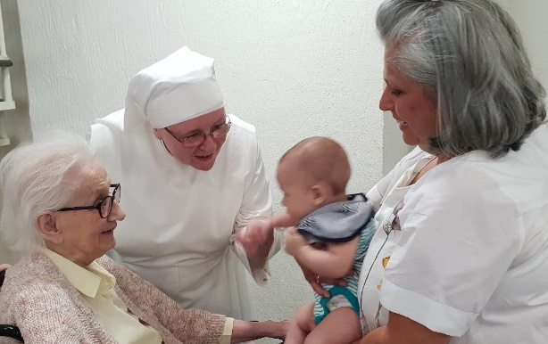

**Fourth World Day of the Poor: Sunday 15 November 2020**

**The Richness of Many Years of Life**

One of the wonderful signs of progress in our society is that people are on average living much longer. Older people uphold and enrich our families and communities, by their caring presence and gifts of time and skills.

But, while we all grow a little bit older every day, too often the signs of ageing are treated as something to be put off or hidden. Many people, Christians included, fear that growing older will bring sadness more than joy. ‘Locked down’ during the Covid-19 pandemic, we may have become more aware of the fragility of all life. Hopefully, we will have been able to share in the joy generated by acts of neighbourly kindness. For many, the lockdown has also brought a deeper encounter with isolation experienced every day by thousands of older people and carers.

As communities start to imagine life after lockdown, and learn from their experiences, it is a good time to reflect on the richness of many years of life. In a message for the Fourth World Day of the Poor, Pope Francis refers to the age-old wisdom found in the Old Testament Book of Sirach: ‘Stretch forth your hand to the poor’ (Sir. 7:32). The Pope reminds us that prayer to God and solidarity with the poor are inseparable. He writes:

*‘Generosity that supports the weak, consoles the afflicted, relieves suffering and restores dignity to those stripped of it, is a condition for a fully human life.’ ‘The power of God’s grace cannot be restrained by the selfish tendency to put ourselves always first.’*

Not having time for the elderly, speaking badly of old age, and excluding older people from the life of communities: these make older people and our whole society the poorer. We should ‘stretch forth’ to neighbours in care homes, living in isolation, struggling to get about or who are bereaved.

Shortly before the pandemic struck, the bishops of England and Wales shared their hope that parishes would consider fresh opportunities for older people to experience more of the care and belonging that they want, and that we would hope to see for ourselves and our loved ones. *Reaching Out,* a practical guide for Catholic parishes and others, includes ten inspiring stories, telling how parishes have brought together people of all ages and added more joy in their local neighbourhoods.

**Could you start what Pope Francis calls ‘a revolution of tenderness’ in your community? *Reaching Out* is available free at:**

[**www.csan.org.uk/embrace**](http://www.csan.org.uk/embrace)

**Prayer for the 2020 World Day of the Poor**

Almighty, ever-living God,  
your beloved Son came to us in poverty to win for us the riches of eternal life.  
During His time on earth He taught us by word and deed.  
From His death we learned of the immensity of His love;  
from His resurrection we learned how to believe and to trust  
that our lives have purpose from beginning to end.

Help us never to forget that every person has value and is loved by You.  
Remind us that, as Your people grow older,  
they do not cease to be people worthy of respect, understanding and appreciation.  
Though the eyes of the elderly may grow dim,   
we pray that their vision of everlasting life with You may grow ever stronger;  
though their bodies may become frail,  
we pray that their faith may empower them;  
though their minds may falter,  
we pray that their memories may bring them comfort and peace.

Lord God, may we never forget your Golden Rule   
to treat others as we would wish to be treated  
and remember to apply that Rule most especially  
during the golden years of age.  
Save us from falling into the trap of seeing the elderly as a burden.

We ask you, Lord God, to help us set aside material wealth  
so as to recognise the spiritual riches of patience, compassion and love for all your people.  
As we journey through this life side by side,  
may we learn to support one another with the combined wealth of  
youth, strength, wisdom and experience  
until we are called to the place you have prepared  
for all those who are poor in spirit and rich in love.

We make our prayer through our Lord Jesus Christ your Son,   
who lives with You and the Holy Spirit, one God, for ever and ever.

Amen.

*We are grateful to a volunteer and the Little Sisters of the Poor for this prayer.*